**Ijyype Iakunenko gerogiy**

**website „Upgrade Life”**

**content**

**Top – Header part**

**Logo**: 

**Nav – menu** :

Sleep

Nutrition & WorkOut

MindSet

**Button** : contact us

**Footer:**

|  |  |  |
| --- | --- | --- |
| Additional information | |  |
| Produced by: | Georgiy Iakunenko | goshanyakunenko@gmail.com |
| Education place: | Elte University | Budapest, Pázmány Péter stny. 1/C, 1117 |
| Release date: | April 21 | 2023 year |

***Remark : footer and top-header part for all pages are the same***

**Home-page:**

**Title** : Significant life improve in 3 steps

**Text:** Why you should always improve your life and try your best?  
  
Personal growth and fulfillment: As human beings, we have an innate desire to grow, learn, and improve ourselves. Improving our lives can bring us a sense of personal fulfillment and help us reach our full potential.  
  
Better health and well-being: By improving our lifestyle habits, such as exercising regularly and eating a healthy diet, we can improve our physical health and overall well-being.  
  
ncreased happiness and satisfaction: Making positive changes in our lives, such as pursuing our passions, can lead to increased happiness and life satisfaction.  
  
Success and achievement: Improving our skills and knowledge can help us achieve our goals and succeed in our careers.  
  
Contribution to society: By improving our lives, we can also contribute to the betterment of society and make a positive impact on the world.



**subtitle** : 3 areas where you need to start to improve your life





**Text – and link in the same time:**

Sleep

Nutrition&WorkOut

MindSet

***Sleep - page***

**Title** : Sleep



**Text:**

Sleep is a vital aspect of our lives, yet it is often overlooked and neglected. The importance of sleep cannot be overstated as it plays a crucial role in our physical, mental, and emotional well-being. In this article, we will discuss the significance of sleep and provide three steps that can help improve sleep quality.  
Firstly, sleep is crucial for our physical health as it allows our body to repair and rejuvenate itself. During sleep, our body produces proteins that help repair our cells and tissues. Lack of sleep has been linked to various health problems such as obesity, diabetes, and heart disease.

Additionally, sleep is also essential for our immune system as it helps us fight of infections and diseases.  
Secondly, sleep plays a vital role in our mental and emotional health. It helps us regulate our emotions, reduce stress, and improve our cognitive function. Lack of sleep has been linked to depression, anxiety, and other mental health disorders. Getting enough sleep can significantly improve our mood and overall well-being.  
Lastly, sleep is essential for our productivity and performance. It helps us stay alert, focused, and energized throughout the day. Lack of sleep can negatively impact our ability to concentrate and make decisions. Getting enough sleep can improve our cognitive abilities, creativity, and problem-solving skills.

**Subtitle:** three steps that can help improve sleep quality:

1. Step1: Stick to a sleep schedule: Our body has an internal clock that regulates our sleep-wake cycle. Going to bed and waking up at the same time every day can help regulate our internal clock and improve our sleep quality. It's essential to be consistent with our sleep schedule, even on weekends.
2. Create a bedtime routine: Creating a bedtime routine can help signal our body that it's time to sleep. Our bedtime routine can include activities such as taking a warm bath, reading a book, or practicing relaxation techniques such as meditation or deep breathing exercises.
3. Create a bedtime routine: Creating a bedtime routine can help signal our body that it's time to sleep. Our bedtime routine can include activities such as taking a warm bath, reading a book, or practicing relaxation techniques such as meditation or deep breathing exercises.

**Btn:** Nutrition&WorkOut

***Nutrition and WorkOut - page***

**Title:** Nutrition and WorkOut

**Text:** In today's fast-paced world, it can be challenging to find the time to prioritize our health and fitness. However, a healthy lifestyle, which includes regular exercise and good nutrition, is essential for our physical and mental well-being. In this article, we will discuss the importance of exercise and good nutrition and provide four steps that can help improve these areas.



**Subtitle :** The Importance of Exercise

**Text :** Regular exercise is critical for our overall health and well-being. Exercise can help reduce the risk of chronic diseases such as obesity, diabetes, and heart disease. Additionally, exercise can improve our mood and mental health by releasing endorphins, which help us feel happy and reduce stress.



**Subtitle :** The Importance of Good Nutrition

**Text:** Eating a healthy and balanced diet is crucial for our physical and mental health. A good diet can help reduce the risk of chronic diseases and help us maintain a healthy weight. Additionally, a healthy diet can improve our mood and energy levels, which can help us stay focused and productive.

**Subtitle :** Four Steps to Improve Exercise and Good Nutrition

**Section steps:**

Set Realistic Goals: The first step to improving our exercise and nutrition is to set realistic goals. We should start by setting small, achievable goals and gradually increase the difficulty level. For example, if we are new to exercising, we can start by walking for 10-15 minutes a day and gradually increase the duration and intensity of our workout.

Create a Plan: Once we have set our goals, we need to create a plan to achieve them. We can create a workout schedule and plan our meals in advance. This can help us stay on track and avoid making unhealthy choices due to lack of time or preparation.

Seek Professional Help: If we are new to exercising or have a specific health condition, it's essential to seek professional help. We can consult with a personal trainer or a registered dietitian who can help us create a workout and nutrition plan that's tailored to our individual needs and goals.

Practice Consistency: Consistency is key when it comes to improving our exercise and nutrition. We should aim to exercise and eat healthy foods regularly, even when we don't feel motivated. Making exercise and good nutrition a part of our daily routine can help us develop healthy habits and improve our overall well-being.

In conclusion, regular exercise and good nutrition are essential for our physical and mental well-being. By setting realistic goals, creating a plan, seeking professional help, and practicing consistency, we can improve our exercise and nutrition and reap the benefits of a healthy lifestyle.

**Btn :**

go back to sleep page

Go next

***Mind Set - page***

**Title:** MindSet

**Subtitle :** The Importance of Mindset

**Text:**

Our mindset is a crucial aspect of our personal and professional development. Our mindset determines how we perceive the world, our ability to handle challenges, and our willingness to take risks. In this article, we will discuss the importance of mindset and highlight three people who have amazing mindsets.

Our mindset is the lens through which we view the world. It shapes our beliefs, values, and attitudes. A positive mindset can help us overcome challenges, achieve our goals, and improve our overall well-being. Conversely, a negative mindset can hold us back and prevent us from reaching our full potential.

Pictures that are also a thumbnails





**Text:**

1. Will Smith: Will Smith is a well-known actor, producer, and rapper. He is also an advocate of positive thinking and personal development. He often talks about the power of visualization, setting goals, and taking action to achieve them. He believes that our thoughts and beliefs can shape our reality and that we have the power to create the life we want through our mindset.
2. David Goggins: David Goggins is a retired Navy SEAL and ultramarathon runner. He is known for his incredible mental toughness and resilience, which he developed through years of training and challenging himself in extreme environments. He advocates for the power of mindset and emphasizes the importance of pushing past our limits and embracing discomfort to achieve our goals. He also emphasizes the importance of self-discipline, hard work, and dedication to success.
3. Jordan Peterson's mindset emphasizes personal responsibility, growth, and meaning. He encourages individuals to take responsibility for their lives and to actively work towards self-improvement, setting clear goals and working hard to achieve them. He also emphasizes the importance of developing a strong sense of meaning and purpose in life, as well as the value of facing and overcoming challenges in order to develop resilience and character. Overall, Jordan Peterson's mindset is focused on empowering individuals to take control of their lives, pursue their goals, and find meaning and fulfillment in the process.

Video : <https://www.youtube.com/watch?v=3uLDin9A9pc&ab_channel=TheDiaryOfACEO>

# Name: Jordan Peterson: How To Become The Person You’ve Always Wanted To Be | E113

**Text :** In this video, Jordan Peterson offers practical advice on how to become the person you've always wanted to be. He emphasizes the importance of setting clear goals, taking responsibility for your life, and developing a strong sense of purpose and meaning.

Jordan Peterson also talks about the importance of facing and overcoming challenges in order to develop resilience and character. He encourages viewers to confront their fears and take on difficult tasks, even if it means experiencing discomfort or uncertainty.

Throughout the video, Jordan Peterson provides concrete examples and strategies for how to develop a more positive and empowered mindset, such as practicing gratitude, cultivating positive relationships, and developing a growth-oriented mindset.

Overall, the video offers practical insights and advice for anyone looking to improve themselves and achieve their goals, and is well worth watching for anyone interested in personal development and growth.

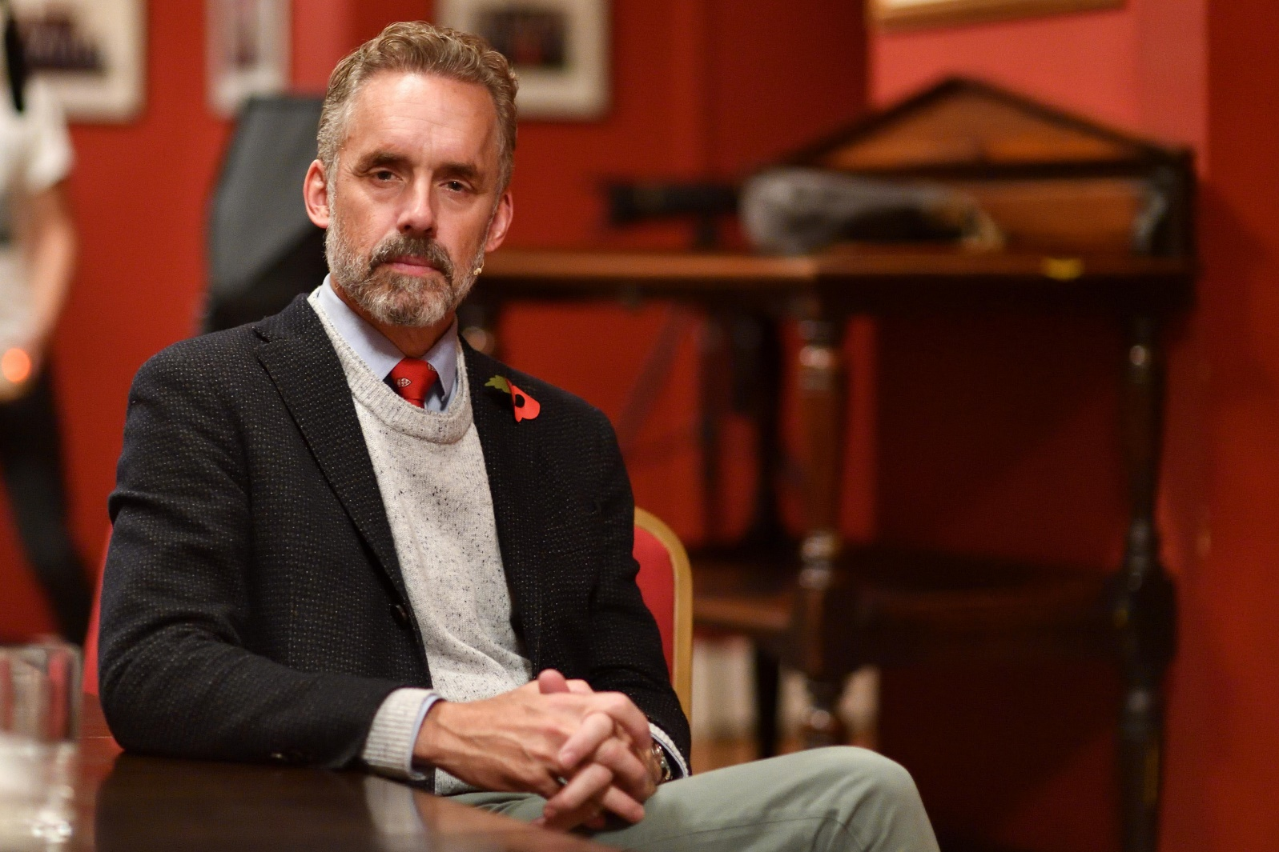

**Background-image for video-click area.**

**Btn:** back to WorkOut and Nutrition / go to homepage

***Form – popUp***

**Input:** please write your email address

**Radio:** please choose your gender : male / female

**Text area:** please write your message

**Checkbox :**

I take full responsibility for everything that I wrote in text area

**Button** : send / clean form

*Author: Iakunenko Georgiy (*[*goshanyakunenko@gmail.com)*](mailto:goshanyakunenko@gmail.com))Budapest, Pázmány Péter stny. 1/C, 1117